PDS Assignment-2

Hari chandra prasad Pasupuleti

16341883

1. Folder creation.

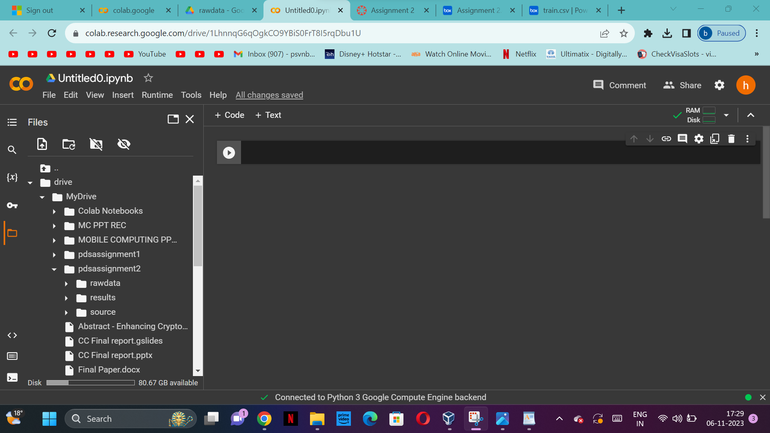

* Importing the packages and checking the data information.

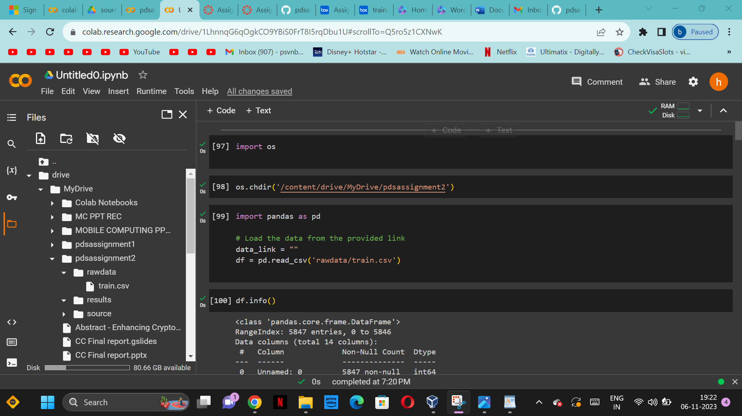

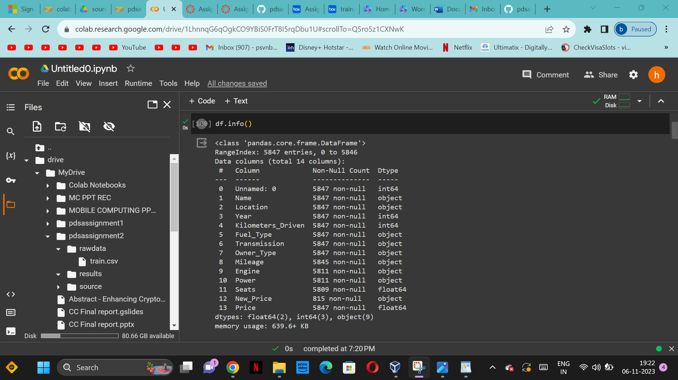

B)Remove the units from some of the attributes and only keep the numerical values (for

example remove kmpl from “Mileage”, CC from “Engine”, bhp from “Power”, and lakh from

“New_price”).

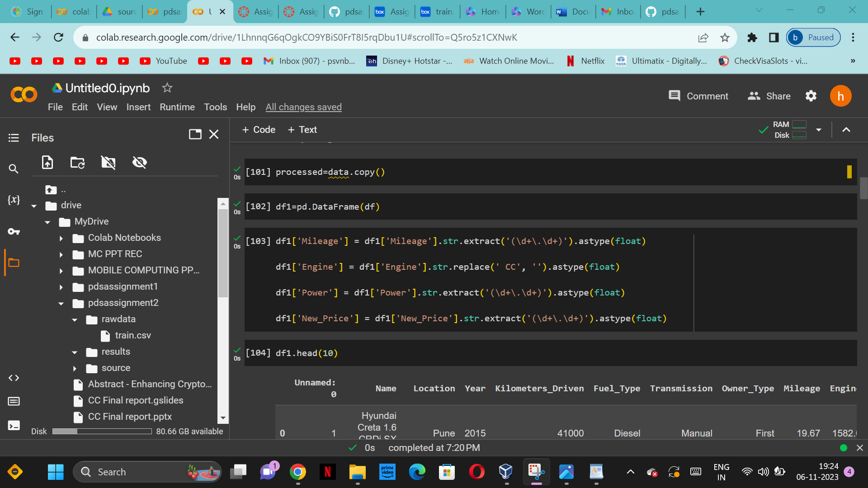

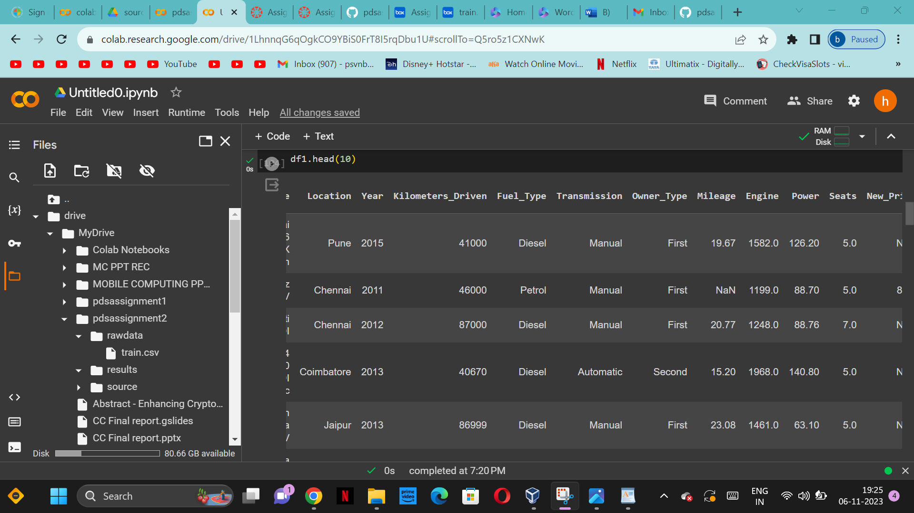

A)Look for the missing values in all the columns and either impute them (replace with mean,

median, or mode) or drop them. Justify your action for this task.

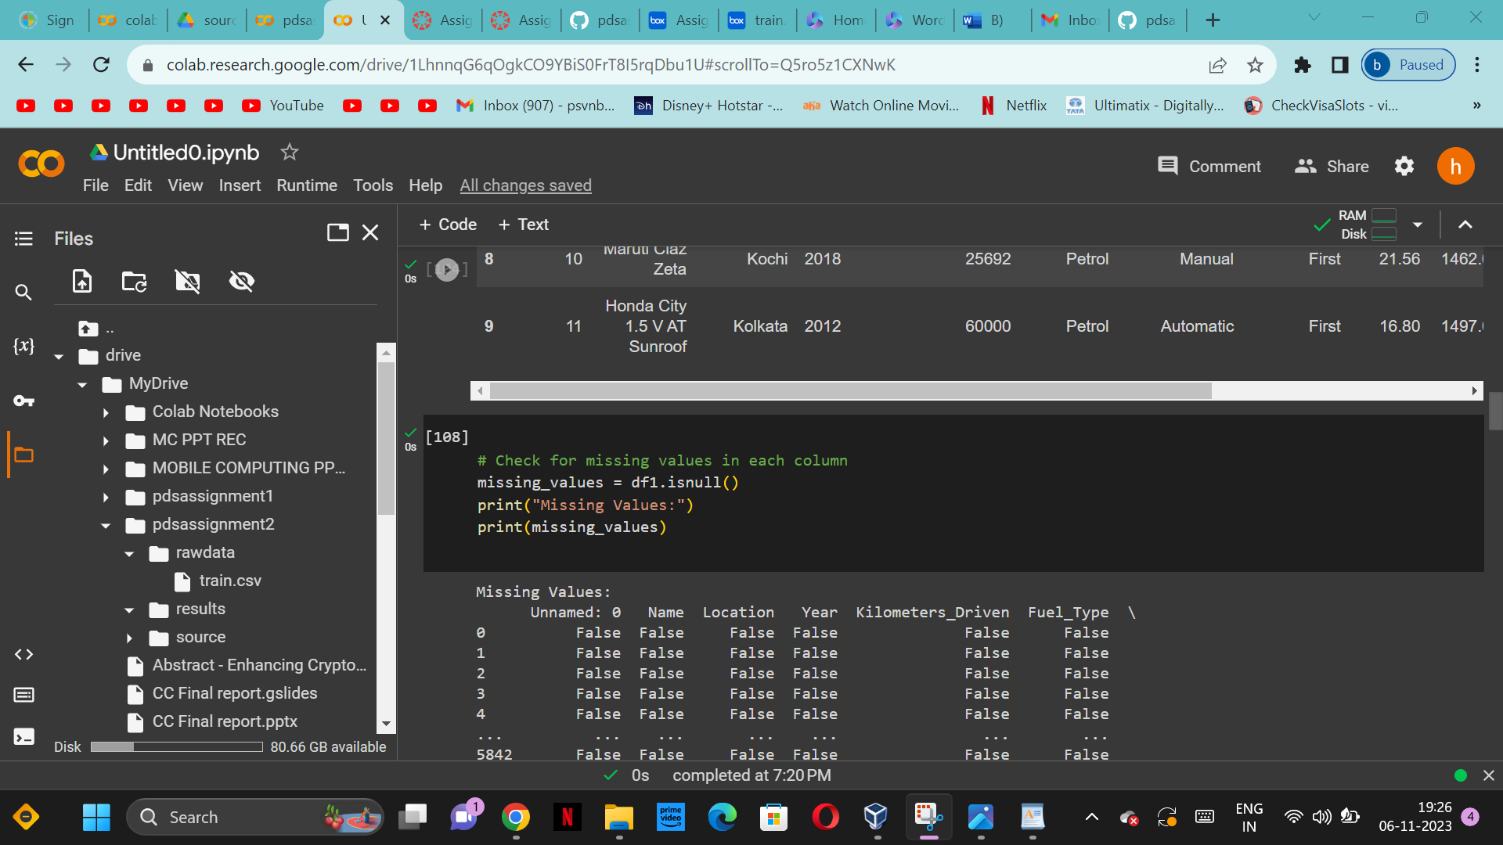

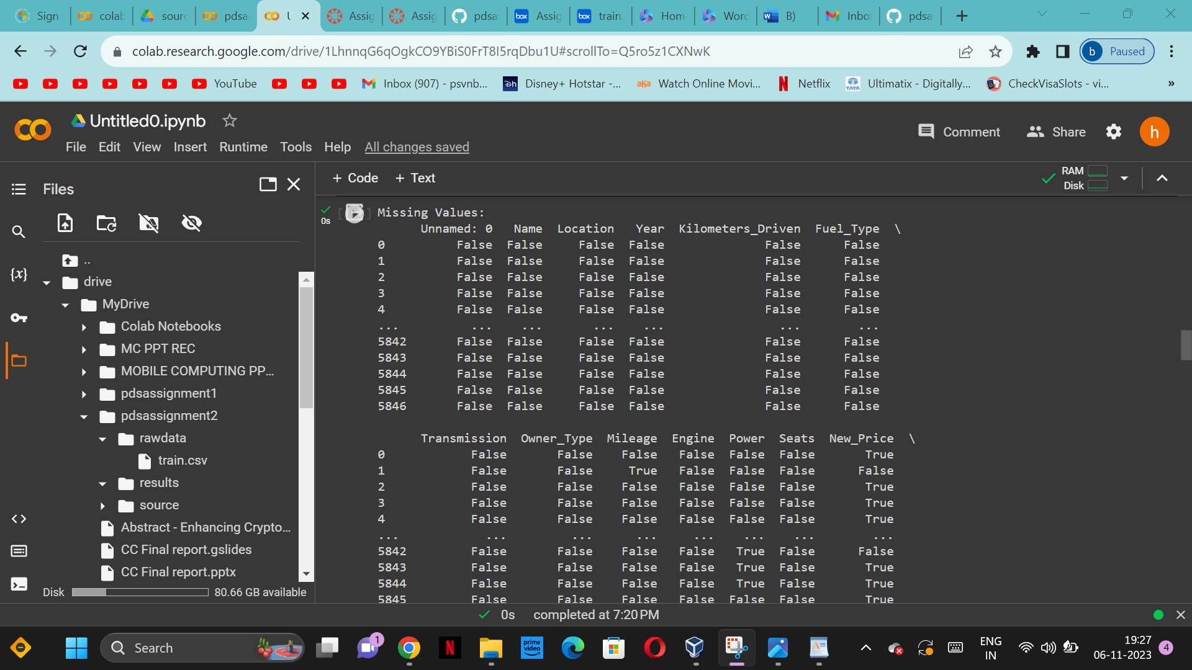

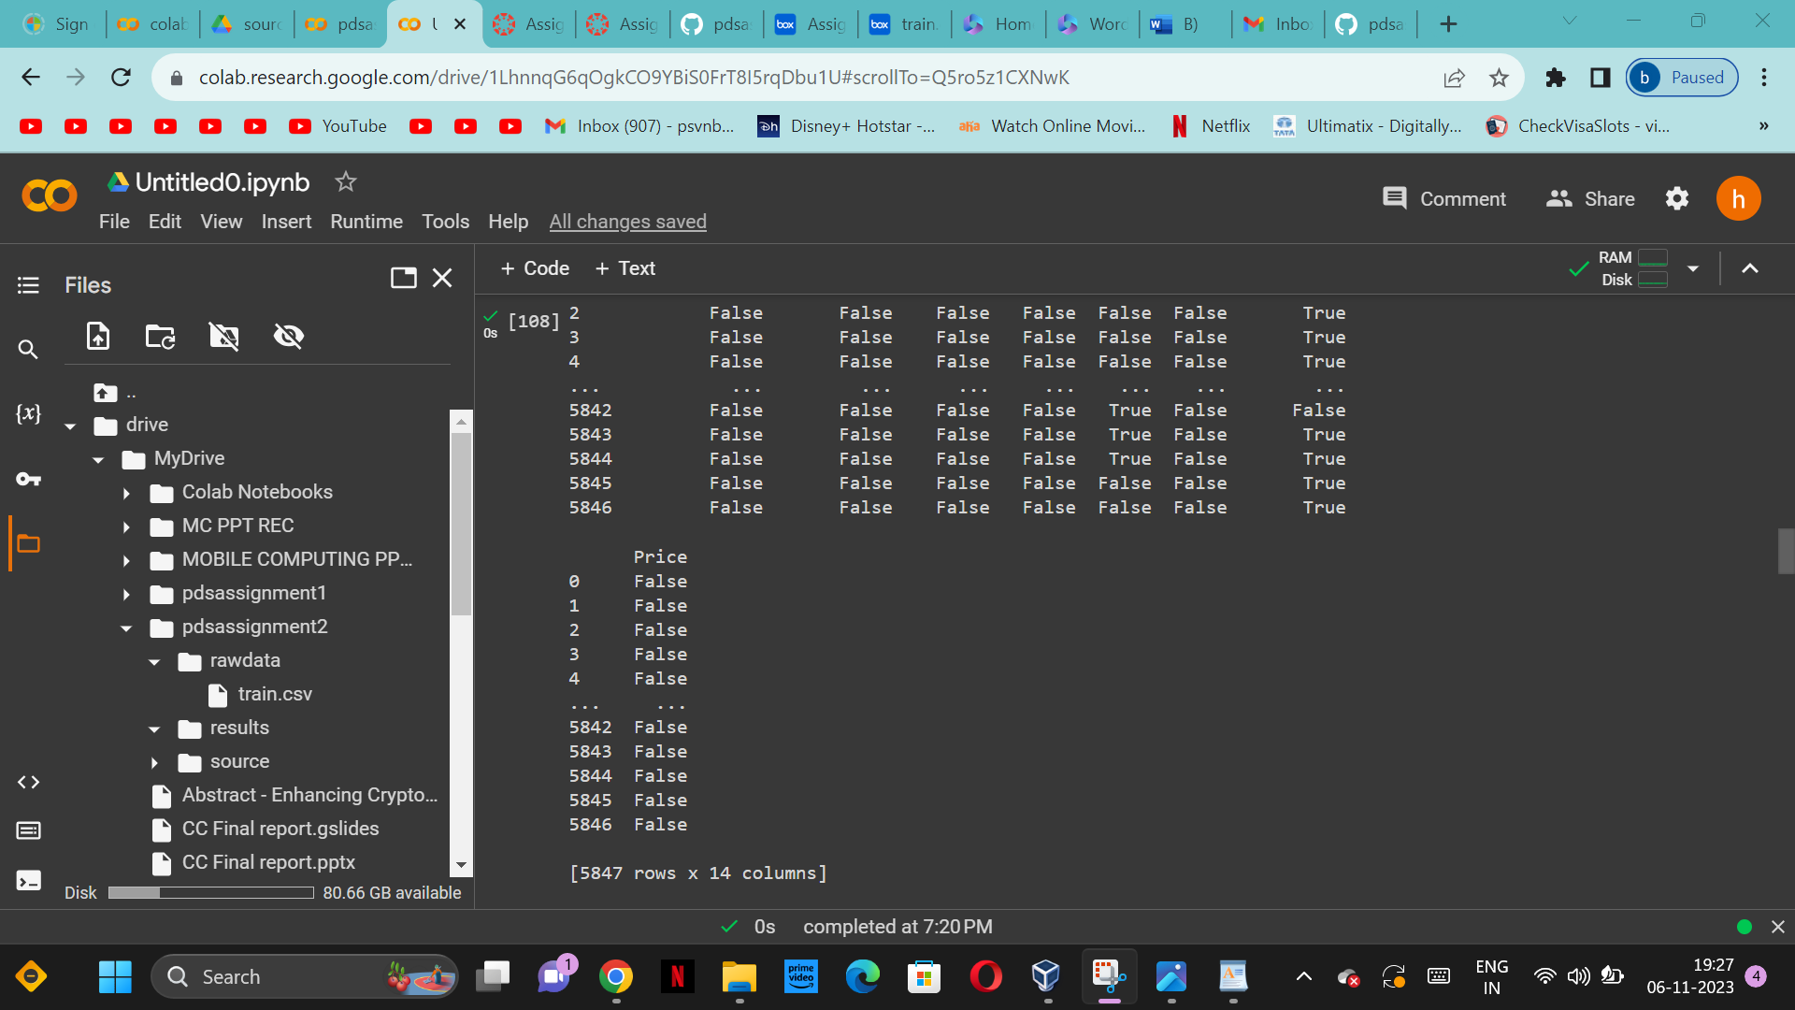

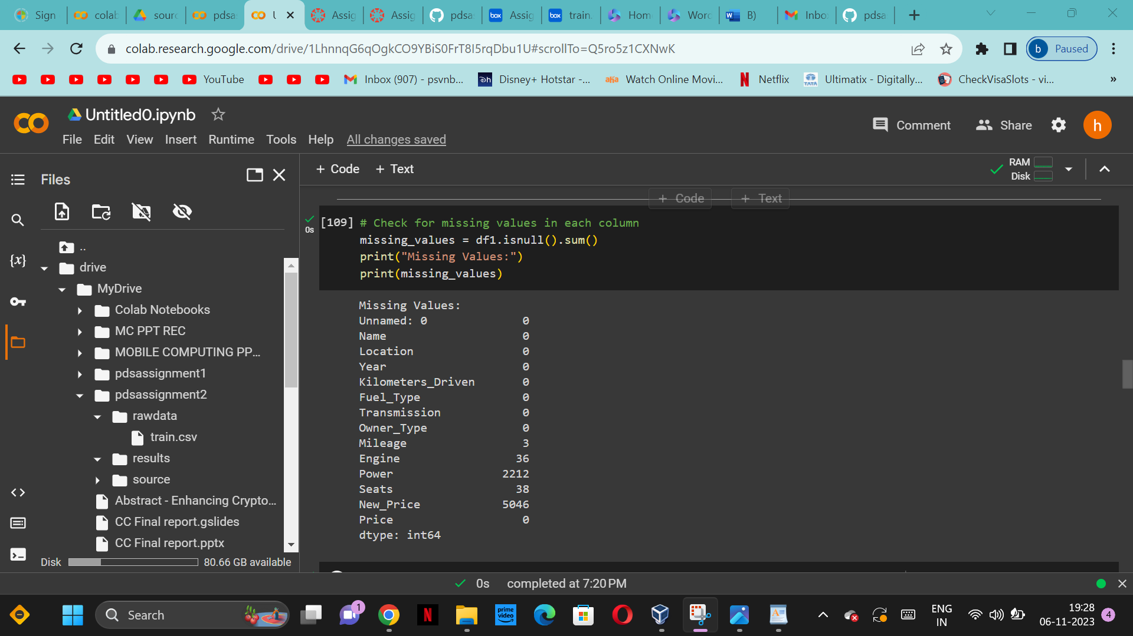

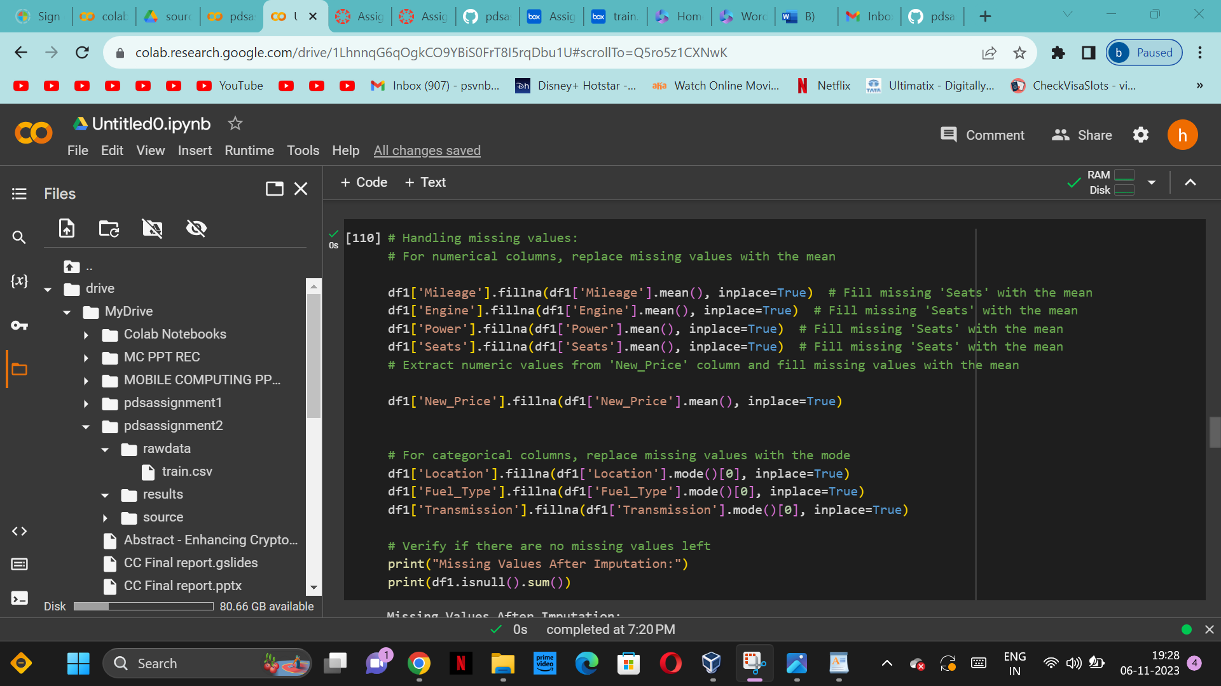

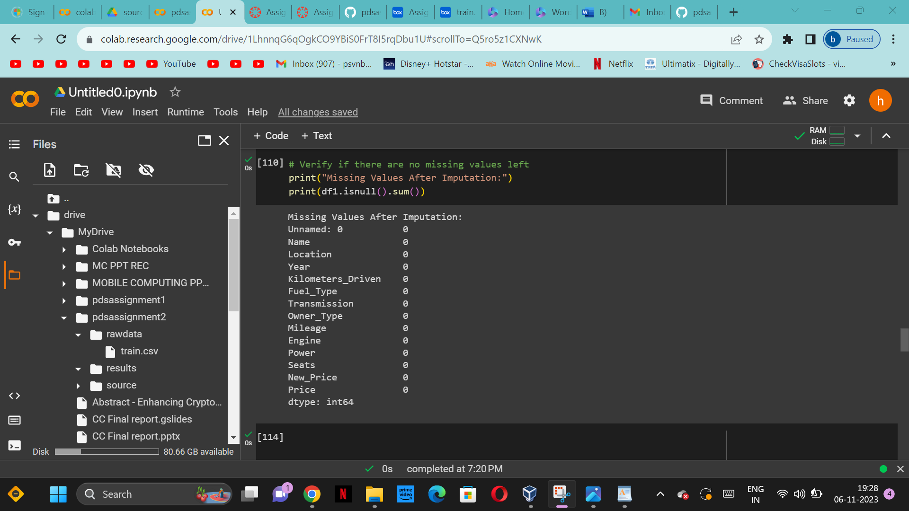

C)Change the categorical variables (“Fuel_Type” and “Transmission”) into numerical one hot

encoded value

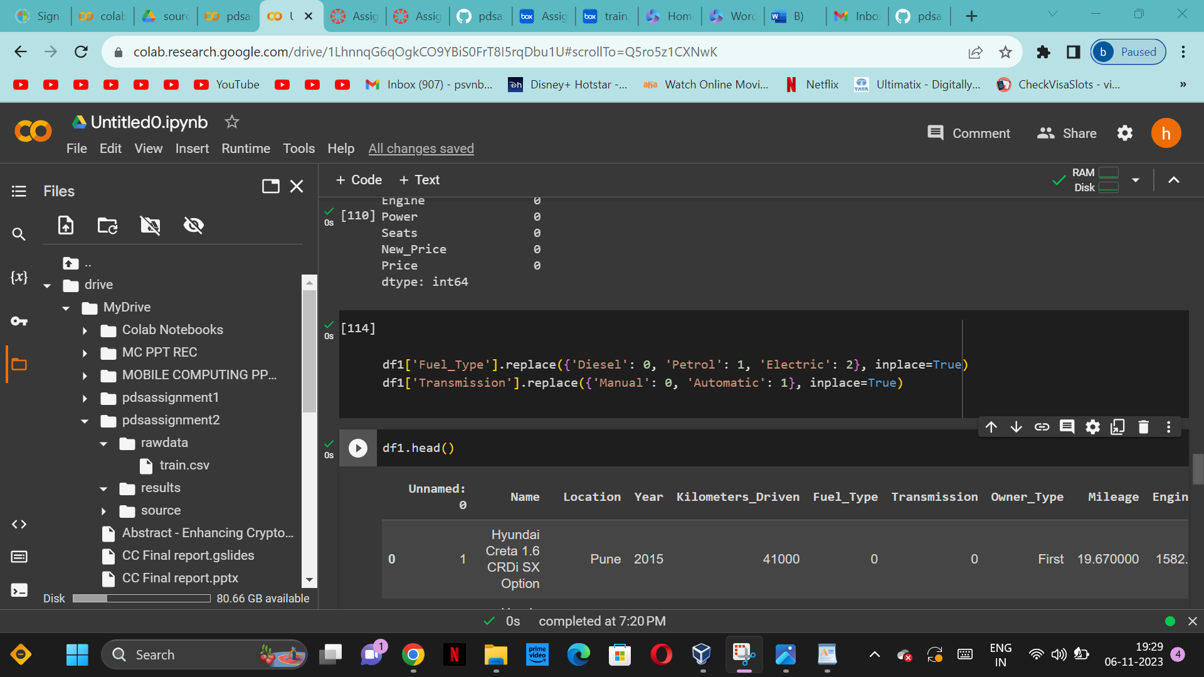

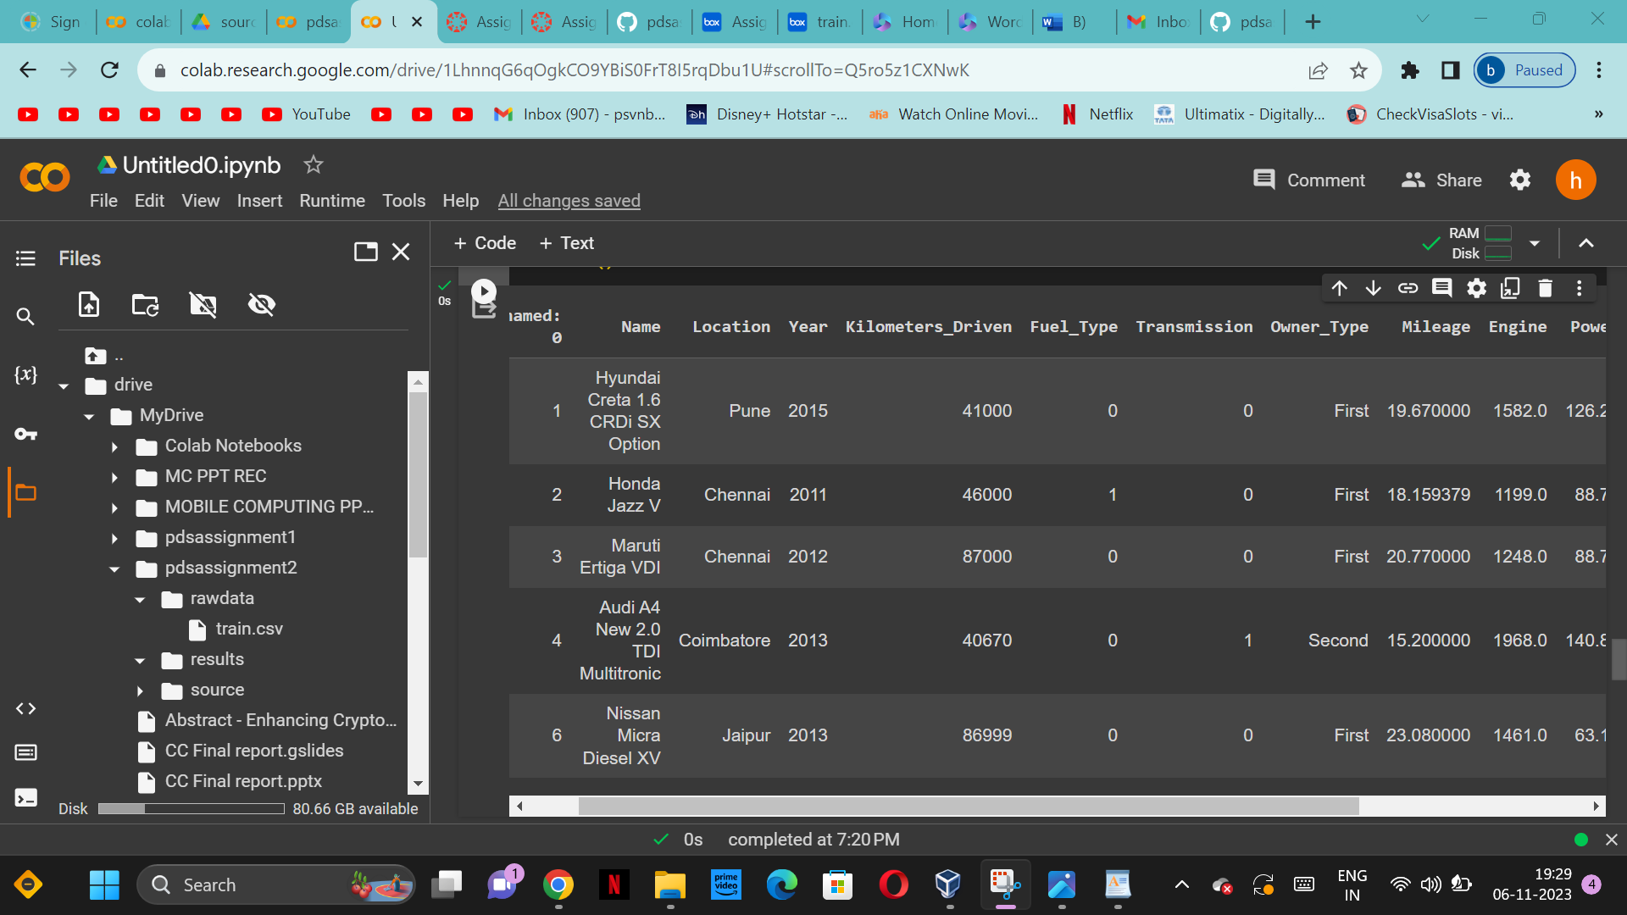

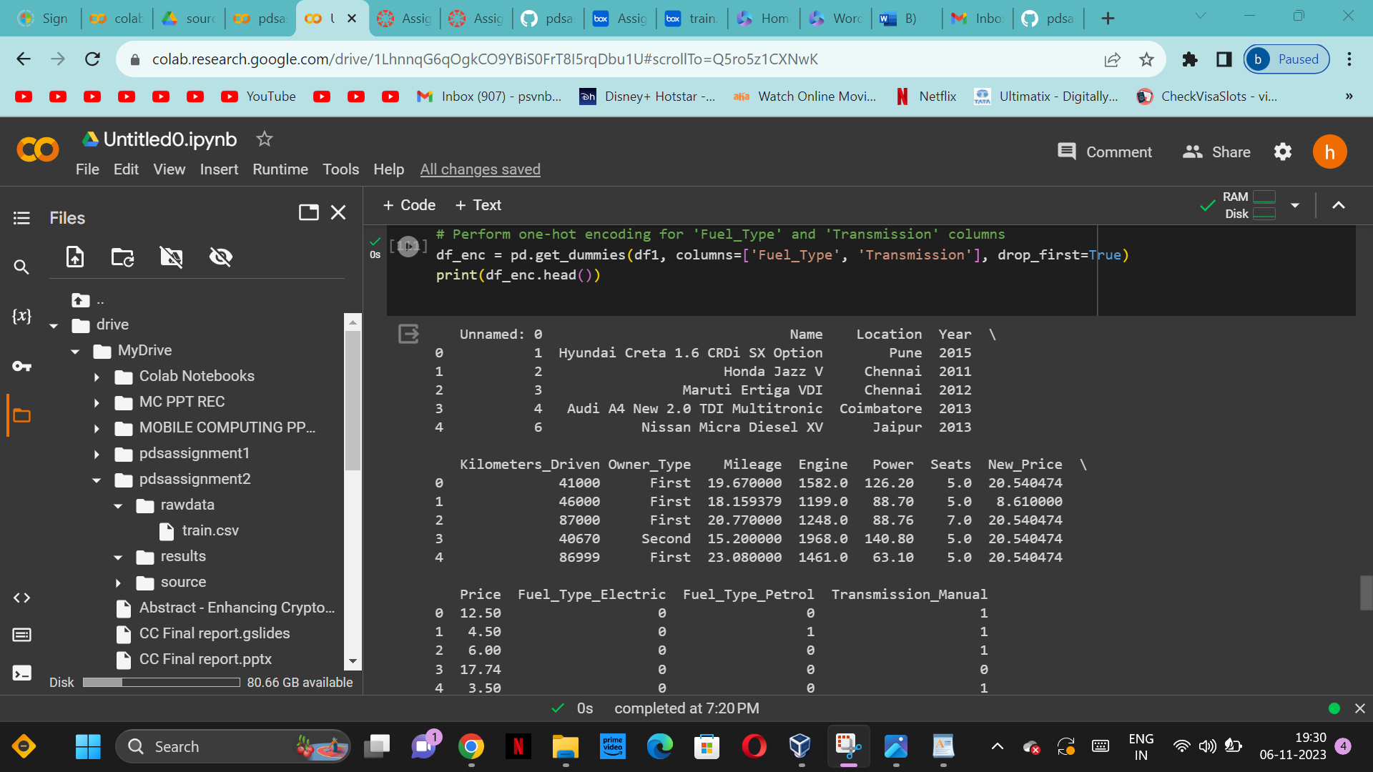

D)Create one more feature and add this column to the dataset (you can use mutate function in

R for this). For example, you can calculate the current age of the car by subtracting “Year” value

from the current year.

